**CloudFront**

Amazon CloudFront is a fast content delivery network (CDN) service that securely delivers data, videos, applications, and APIs to customers globally with low latency, high transfer speeds, all within a developer-friendly environment

So what are my exam tips?

Really you just need to understand what CloudFront is at a high level.

You need to understand what edge locations are.

**Edge locations** - So it's the location where content's gonna be cached, and it's very separate to an AWS region or availability zone. We have edge locations all over the world.

**Origin -** You need to understand what an **origin** is, and this is basically just the source of the files that your CloudFront distribution will distribute. And this can either be an S3 bucket, can be an EC2 instance, can be an Elastic Load Balancer, or Route 53, et cetera, et cetera.

**Distribution -** Then we have our **distributio**n. So this is just the name given to the CDN, which is a collection of edge locations. And our distributions can either be a **web distribution**, which is the one that we just set up, or an **RTMP** distribution, which is used for Adobe Flash Media Streaming.

And then moving on, edge locations are not just read only. So we saw that when we were looking at transfer acceleration. You can write to them, too, so you can put an object on them. And **objects** are cached for the life of the **TTL(time to life)**, so they're cached for the life of the time to live, and that's always in seconds. And like we just saw, you can invalidate cached objects, but you are going to be **charged**.

So going into the exam,just remember to use signed URLs and cookies when you want to **secure content** so that only the people that you authorize are able to access it.

- Remember that the **assigned URL** is for **individual files** and one file equals one URL.

- A **signed** **cookie** is for access to **multiple files**.

So one cookie allows you to access multiple files, and that's what we use at A Cloud Guru and then remember that if your origin is EC2 then you want to use CloudFront. If your origin is going to be S3 and you've only got a single file in there then you want to use a S3 signed URL instead of a CloudFront signed URL.

**Snowball**

Well, this is a Snowball, this is what they look like.They're basically big, big disks. So a Snowball is a petabyte-scale data transport solution that uses secure appliances to transfer large amounts of data into and out of AWS. So, like I said, it's a big disk. It's a way of getting huge amounts of data into AWS. And you can also use it to export data from AWS.

Snowball can import big load of data to S3 and export it.

**Storage Gateway**

So what are my exam tips?

- **File Gateway**. This is NFS and it's for flat files and it's going to be stored directly on S3. - **Volume Gateway** which is using iSCSI and it consists of two different volumes. So we've got stored volumes.

- **Stored volumes** are your entire dataset to be stored on S3.

- Then we've got **cached volumes** and this where your entire dataset is still stored on S3 but the most frequently accessed data is cached on site. And with stored volumes, the entire dataset is stored on site. So that's the difference. Stored volumes is you've got your entire dataset on site, cached volumes is where you've only got your most frequently accessed data cached on site.

- **Gateway Virtual Tape Library**.

And I have been, like I said as well, we were talking about that these were virtual appliances or virtual machines. You can also get physical Storage Gateway appliances as well now.

**Athena vs. Macie**

**Athena**

What is Athena?

Well, Athena is an interactive query service, which enables you to analyze and query data located in S3 using standard SQL. So this is a really cool service, you can basically use SQL. This, effectively allows you to turn S3 into a giant database and you can actually query S3 using standard SQL. Now the cool thing about Athena is that it's serverless. There's nothing to provision you pay per query or per terabyte scanned. There's no need to set up complex extract transform load or ETL(ETL = extract transform load: is a process that extracts the data from different source systems ) processes. So how do you get your data out of S3? How do you put it into something like RDS? You don't need to worry about any of that Athena will basically allow you to turn S3 into a database, you can run SQL queries against it. And it works directly with data stored in S3.

**PII**

What is **PII**?

PII is just personally identifiable information.And this is information that's used to establish a person's identity. So this data could be exploited by criminals and used in identity theft or financial fraud. Some examples of PII might be your home address, it could be your email address, it could be your social security number, your passport number, your driver's license number, your credit card numbers, your date of birth, phone number, bank account number, credit card number, et cetera. That's all that PII is.

**Macie**

Well, Macie is a security service that uses machine learning and natural language processing or NLP to discover, classify and protect sensitive data stored in S3. So it uses AI to recognize if your S3 objects contain sensitive data such as PII and it basically gives you dashboards, reporting and alerts. And it works directly with the data stored in S3. And it can also analyze CloudTrail logs. And this is great for PCI DSS. So if you're taking credit card payments on your website, as well as preventing ID theft. Now you can see why people get the two confused because Athena allows you to query your data on S3 based on SQL commands that you write. However, Macie queries data on S3, but it's using machine learning and natural language processing to discover PII information. So there's similar but different services.

**CONCLUSION OF Chapter 4**

**IAM**

So, we learnt that **identity access management** consists of the following.

So, it consists of **users**, **groups**, **roles** and then you apply policies to these three different things. So, you **apply policie**s to your **users**, **groups** and **roles**.

If you apply a policy to your group and you've got users within that group, they're going to inherit that policy automatically.

Now, I know we didn't really cover off roles much in this section of the course. We are going to look at it in more detail in the next section of the course. We did create a role when we turned on cross region replications. If you actually go into IAM and have a look at your roles, you'll see a role there for cross region replication.

We also learnt that **IAM is universal**, it does not apply to regions at this time.

The **root** account is simply the account that's created when you first set up your AWS account and it has complete administrator access.

**New users** have no permissions when first created and you'll find this is a theme within Amazon. It's called least privilege. So, whenever you create a new user, that user's not going to have any rights or any privileges until you grant them privileges.

Likewise when we look at S3, when we create our bucket, it's locked down, it's not public and making objects public is not that easy. You have to go through a process to do it. So, that's a common theme within Amazon Web Services.

**New users** are assigned an access key ID and secret access key when first created. These are not the same as a password. You cannot use the access key ID and secret access key to log into the console. You use it to access AWS via the APIs and the Command Lines, however. And you only get to view your access key ID and secret access key once. If you lose them you have to regenerate them. So, make sure you save them in a secure location.

**S3**

Let's look at S3. So, remember that S3 is object based. It allows you to upload files and those files can be zero bytes all the way up to five terabytes and there is unlimited storage and you store your files in these things called buckets and it's basically just a folder in the cloud.

Now, S3 is a universal namespace so that means that your buckets must, bucket names must be **unique**. Now, remember that S3 is **object-based storage** so it's not suitable to install an operating system on or a database or anything like that. And then when you upload you know objects to S3 or files to S3.

Now, by default all newly created buckets are **private**. You set up access control to your bucket using bucket policies and bucket policies are bucket wide and then you can also use access control lists and these can go down to the individual files or objects in your bucket.

Now, remember that S3 buckets can be configured to create access logs which logs all requests made to the S3 bucket and these can be sent to another bucket in the same AWS account or even another bucket in another AWS account. And we go into that architecture a lot in the security specialty. There's certain ways you can design your AWS infrastructure to be super secure using multiple accounts.

Moving on, the key fundamentals of S3. So, basically S3, you've got a **key** and this is simply the name of the object. You've then got a **value** and this is simply the data is made up of a sequence of bytes so sometimes people refer to S3 as a key value pair. We then have the **version ID** which we saw when we turned on **versioning**. We have **metadata** so we have data about data that we're storing and we do that through **tags** and then you get some sub resources such as access control lists and then torrents as well.

Now remember, the consistency model going into your exam for S3. So, it's read after write consistency of puts of new objects and eventual consistency for overwrite puts and deletes and this can take some **time to propagate**.

And like I said, what does that mean in everyday language?

Well, if you put an object into S3, you're going to be able to read it immediately. If you overwrite an object or delete an object in S3 and you read it instantly after that, you could get the old version or you could get the new version. So, sometimes you will get eventually the right version but sometimes it takes some time to propagate.

Then seriously, this is a big exam topics. It's worth at least four or five marks. You have to understand the **different S3 classes of storage**.

So, we've got the **S3 standard**, that's what most people use.

**S3 infrequently accessed**. So, this is where you want the same sort of durability and availability as standard S3 but you, you want to pay a lower fee but you still need instant access to S3 infrequently accessed.

We then have **S3 one zone infrequently accessed**. This is what's only going to be in one availability zone so you have to know a plan for that but it is a much lower cost.

**S3 intelligent tiering** uses machine learning to move your objects around depending on how often you use them.

**S3 Glacier i**s for data archival and you can configure your retrieval time from minutes to hours.

And then we have **S3 Glacier Deep Archive** and this is basically Amazon's lowest cost storage class but you will have a retrieval time of 12 hours.

**Pricing** - So, just remember them in this order. It starts off with S3 standard as most expensive, then infrequently access, then S3 intelligent tiering, then S3 one zone infrequently access, then Glacier and then Glacier Deep Archive.

Moving on, let's talk about **encryption**. So, encryption in **transit** is achieved by using HTTP and TLS.(The data that is in transit is encrypted )

On the **server side**, it's achieved by three different ways. So, we've got **S3 managed keys**. This is where S3 just handle all our encryption for us and we don't have to worry about them. Got **AWS key management service or KMS**, this is where we can start using keys from the KMS service and we cover this in an awful lot of detail in the certified security specialty.

And then we've got **server side encryptio**n with customer provided keys. So, this is where you provide your keys and you manage the encryption and the actual maintenance of those keys.

And then we also have **client-side encryption**. So, this is where you encrypt the objects and then you upload them to S3. So, that is encryption with S3 on AWS. We then covered off AWS Organizations

The paying account should be used for billing purposes only. Do not deploy resources into the paying account, into the root account or the master account, it should really just be used for billing and then setting up, you know, things like organizational units, service control policies, et cetera.

And then you can enable and disable AWS services using service control policies or SCPs, either on organizational units which are basically just groups or maybe it's your finance group or your HR group et cetera or on individual accounts themselves. And so, service control policies are basically just like policies in identity access management.

Essentially, they enable or disable services for AWS accounts. So, maybe you don't want your finance team and all the AWS accounts associated with it being able to provision EC2 instances for example and we're going to cover off EC2 in the next section of the course.

And then just remember there's three different ways to **share S3 buckets across accounts**. So, we can do this using **bucket policies** and **identity access management**. And because it's a bucket policy, it applies across the entire bucket and it's programmatic access only. We can do this using bucket **ACLs** and **identity access management**. And because we're using ACLs, this is on individual objects and again this is programmatic access only and then there's **cross account identity access management roles** and this is programmatic and console access.

So, on to **cross region replication**. Basically, for the exam, you really just need to know what it is and if you forget, just look at the name. It's a way of replicating objects across regions but you can also **replicate** them within **the same region**. So, in order for cross region replication to work, you need **versioning** to be **enabled** on both the **source** and the **destination** buckets. Files in an **existing bucket** are **not replicated** automatically so if you turn it on for an existing bucket and then create a new bucket, those files **will not be copied automatically**. However, all subsequent updated files will be replicated automatically. Remember that your delete markers are not replicated so if you delete an object in one bucket, it's **not going to be deleted in the other.** And then deleting individual versions or delete markers **will also not be replicate**d. So, really going into your exam, understand what cross region replication is at a high level.

**Lifecycle policies.**

Moving on to lifecycle policies.

It automates moving your objects between the different **storage tiers**. That's all the policies are and they can be used in **conjunction** with **versioning** and they can be applied to current versions as well as previous versions.

**S3 Transfer Accelerations**

Moving on to **S3 Transfer Accelerations**. So, we have our users, they're all around the world. We have our edge locations. Our users will upload their files to the edge locations first and then those files will go over the AWS backbone network to S3. And we saw how mostly it can improve speed and performance. So, if you do need to increase the performance of your, you know, of your users being able to upload files to S3, look at S3 Transfer Acceleration.

**CloudFront**

Moving on to **CloudFront**.So, we learnt what an edge location was so this is the location where the content is going to be cached and it's separate to an AWS region or availability zone. We learned what an origin was, this is the origin of all our files that the CDN will distribute and this can either be an S3 bucket, an EC2 instance, an elastic load balancer or Route 53. And then we learned what a distribution was and this is simply the name given to the CDN which consists of a collection of edge locations. And then we have two different types of distributions. We've got our web distributions. This is typically used for websites and then we've got RTMP, this is used for Adobe media and it's used for media streaming. Also, with CloudFront, we learnt that edge locations are not read-only, you can write to them as well, i.e. put an object to them. So, we looked at that with Transfer Acceleration. And then objects are cached for the time to live or TTL and that value is always in seconds and then you can clear cache objects by invalidating them

but you will be charged so do remember that.

**Snowball**

**Snowball** So, basically, it's a big disk that you can use to move your data in and out of the AWS cloud and Snowball can be imported into S3. So, you can import data into S3. You can also use Snowball to move large amounts of data

out of S3.

**Storage gateway**

Moving on to **storage gateway**

So, we have **different types** of Storage Gateway.

We've got **File Gateway**, this is used for flat files that are stored directly on S3 and that's NFS.

We then have a **volume gateway**, that's iSCSI and we have two different types of volume gateways. We've got our stored volumes and this means that your entire dataset is stored on site so it's literally a 100% copy of your data being stored on-site and then it's backed up to S3. Then also have cached volumes and this is where the entire data set is stored on S3 and only the most frequently accessed data is cached on site

We also then have gateway **virtual tape library** and this is used for backups and works with really popular backup applications like NetBackup, Backup Exec, Veeam et cetera

and it's a great way of getting rid of your physical tapes.

**EC2 (Elastic compute cloud)**

So the first one is, just remember what EC2 is.

It's virtual machines in the cloud. It's a web service that provides resizable compute capacity. And Amazon EC2 reduces the time required to obtain and boot new servers instances to minutes from ... previously from days or even months depending on where you worked, allowing you to quickly scale capacity both up and down as your computing requirements change.

Remember the different pricing types. So we've got **On Demand**, we've got **Reserved**, we've got **Spot** and we've got **Dedicated Hosts**. On **Demand's** where you pay an hourly or by-second rate, **Reserved** is basically where you sign a one- or three-year contract, and the more you pay upfront, the better discount you get. **Spot** moves around like the stock market, and really just depends on Amazon's own supply and demand. And then we've got **Dedicated Hosts**, and this is where you get a dedicated physical machine to you and you can also, again, pay for that on-demand as well. And then just remember that if you've got a spot instance that has been terminated by EC2, you're not going to be charged for a partial hour of usage. However, if you go in and terminate that instance yourself, you will be charged for the hour in which the instance ran. Is just Fight-Dr-McPx-Z in Australia or in Austin. So there's Dr-McPx-Z, we're going to go and fight her in Australia or Austin. It's silly, I know, but it really, really does help you remember all the different instance types.

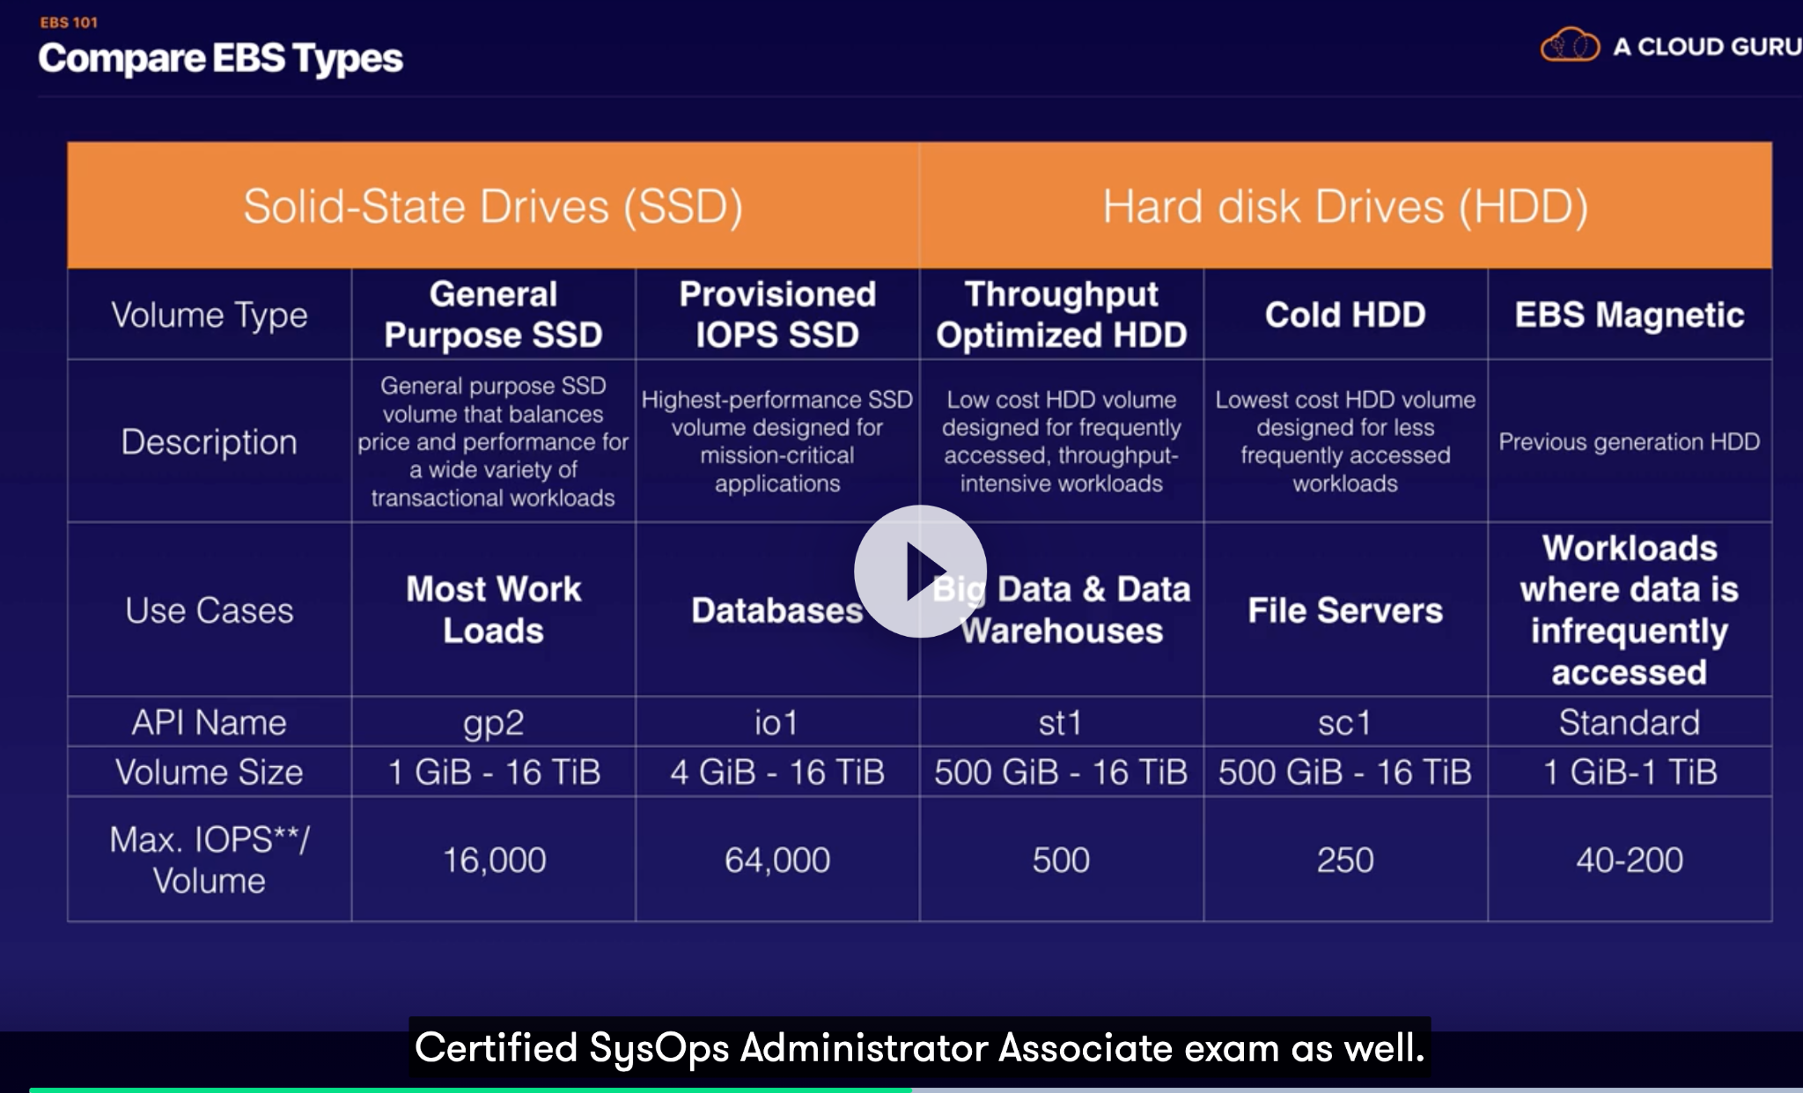

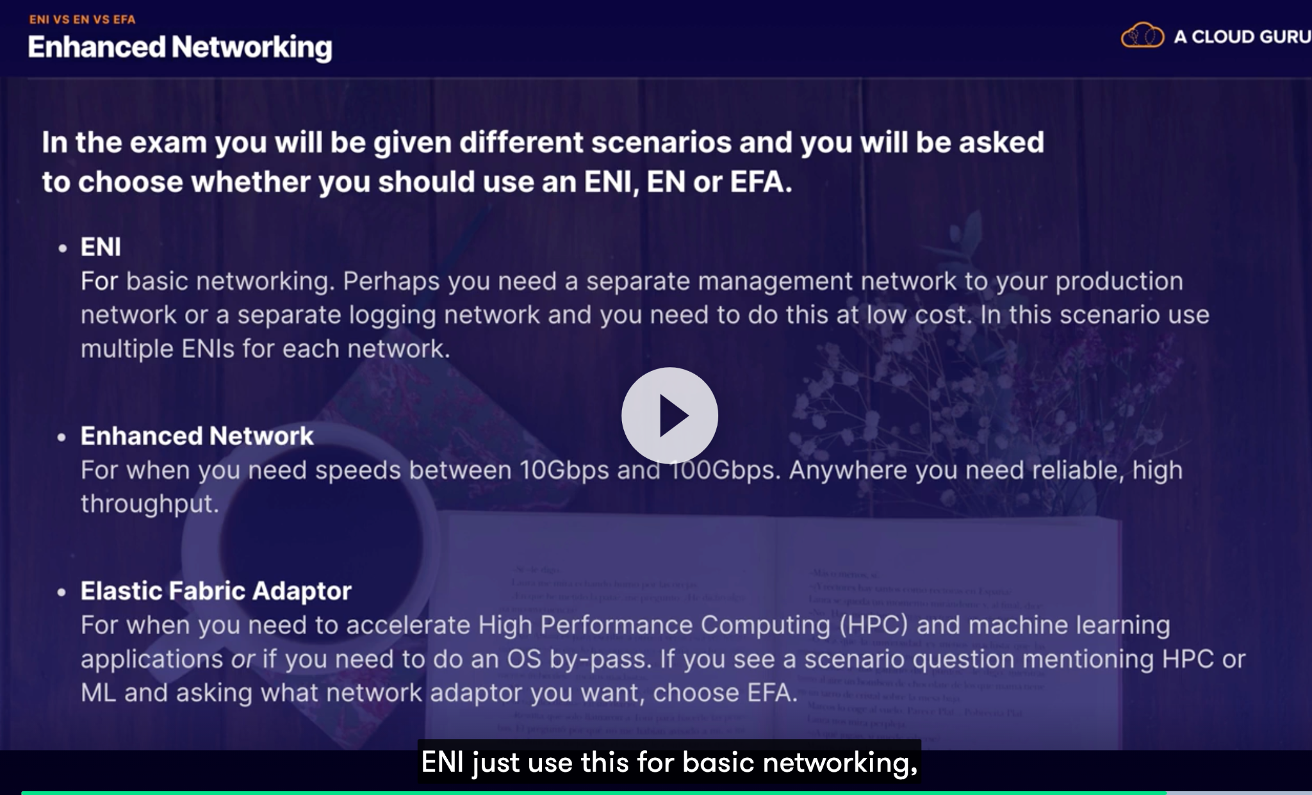

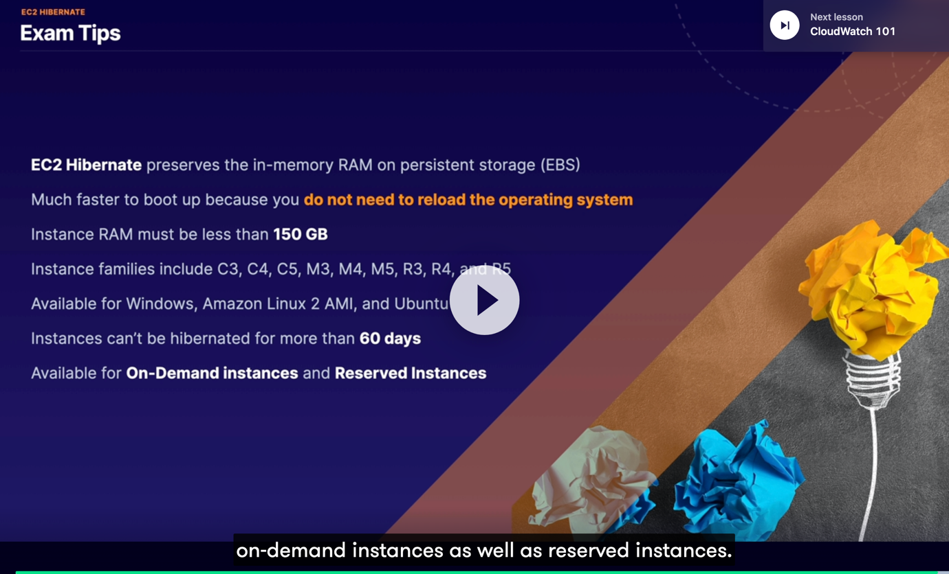

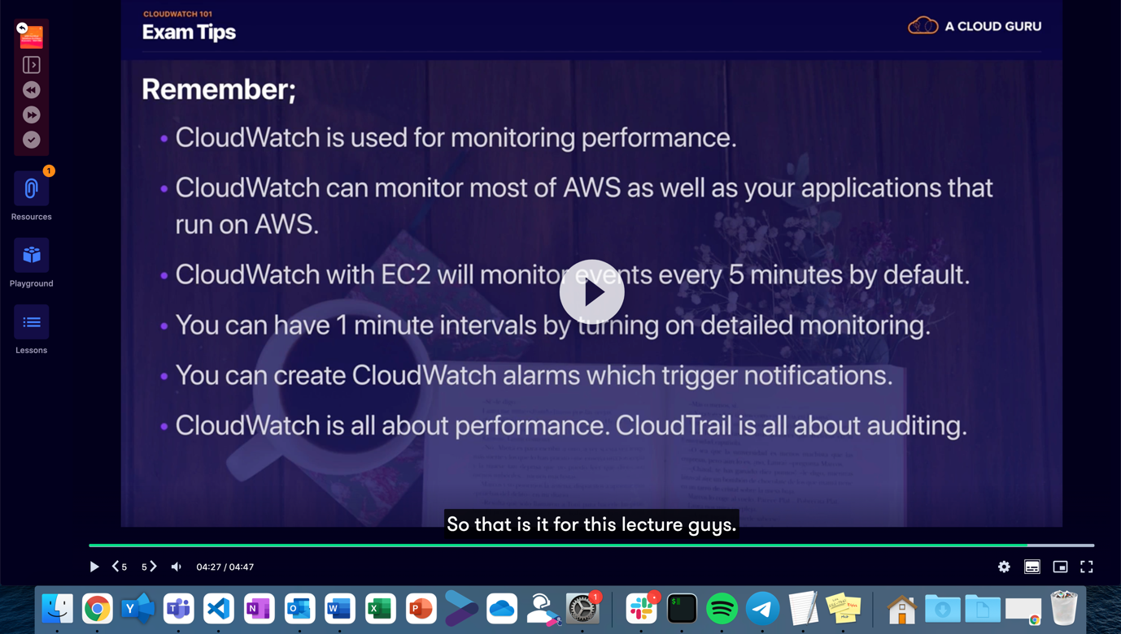

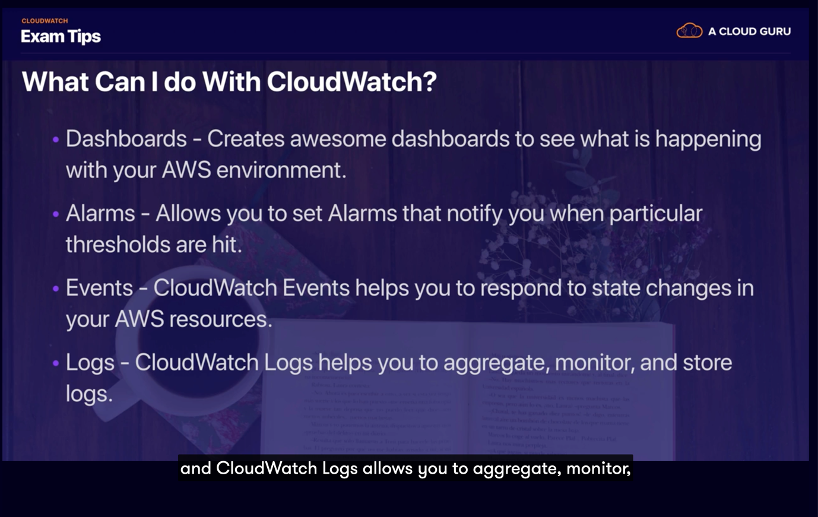

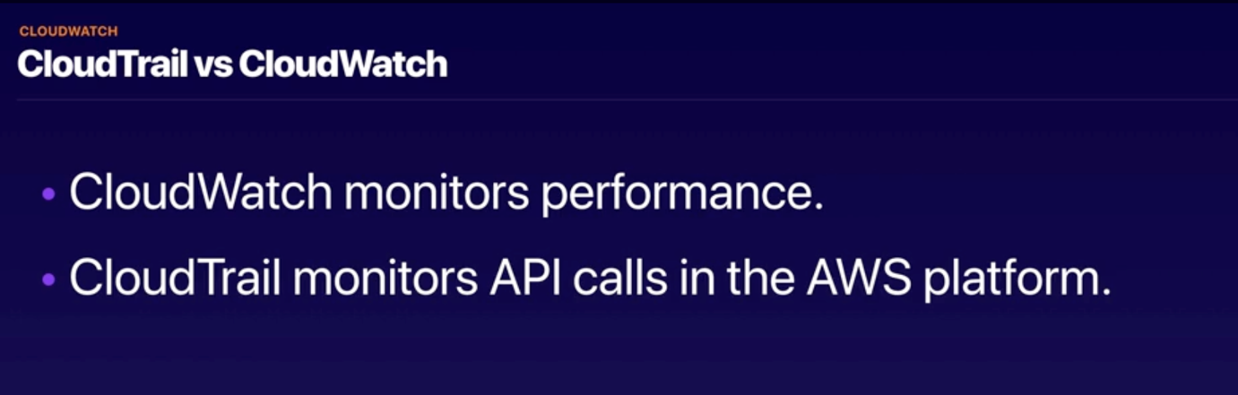

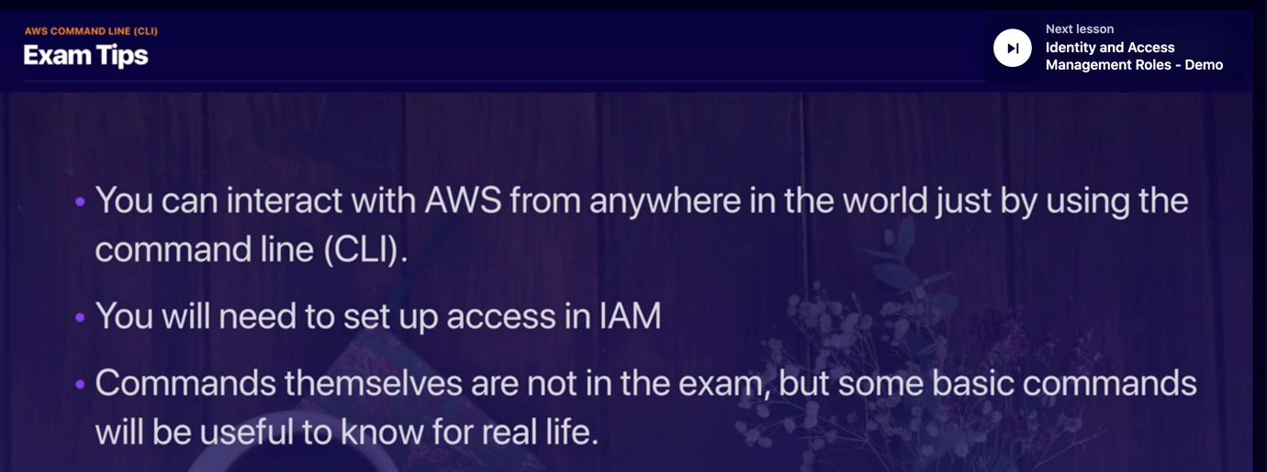

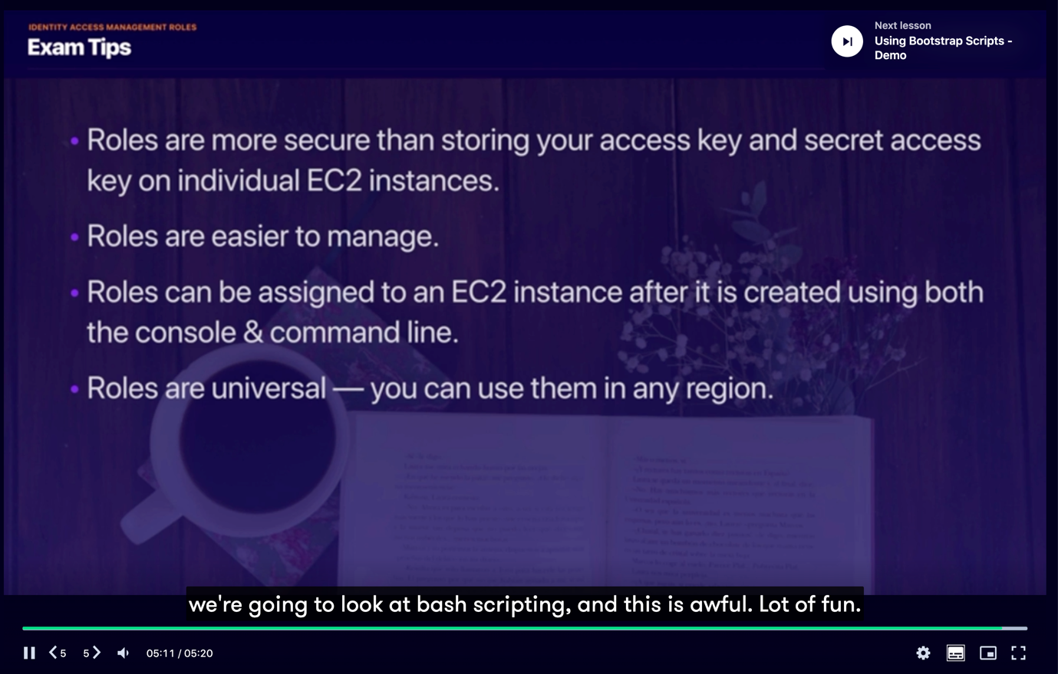

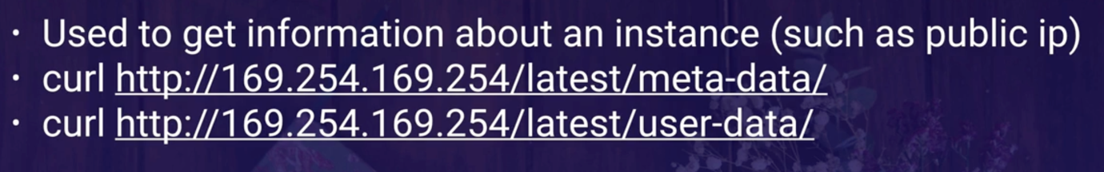

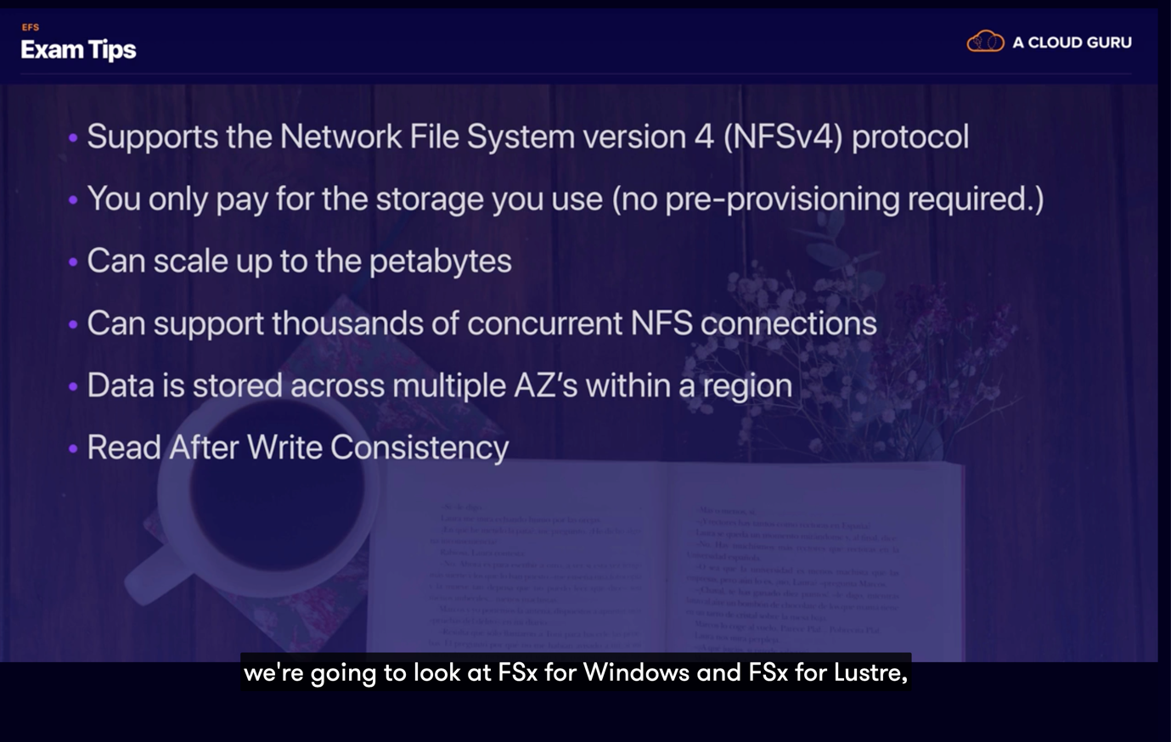

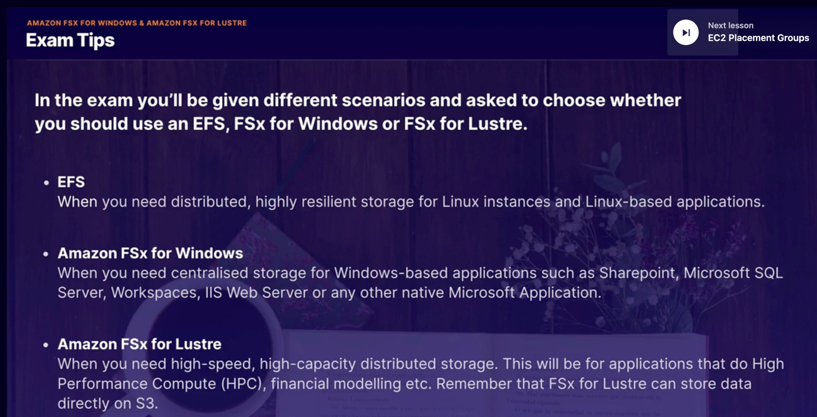

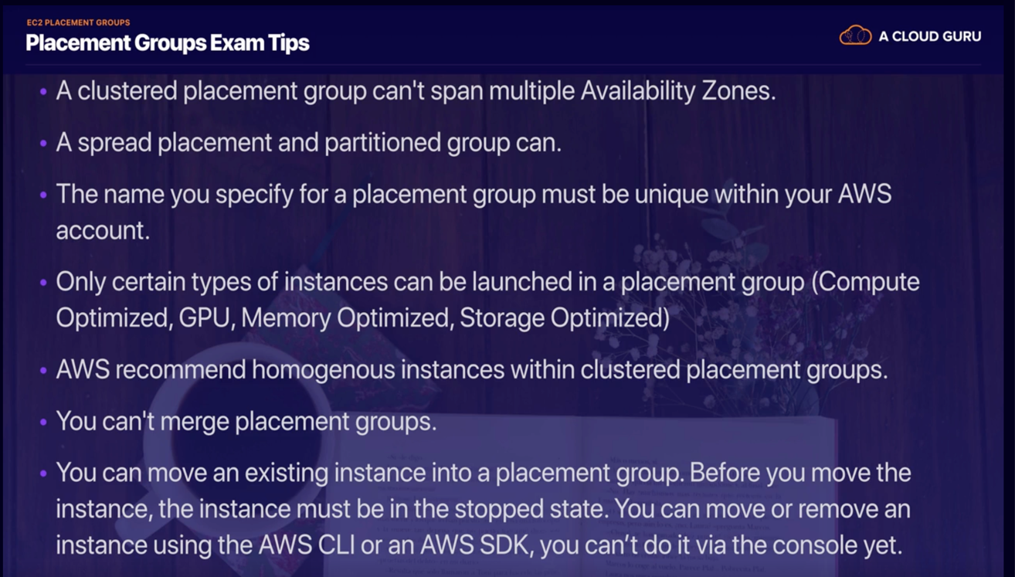

**HPC (High performance compute)**

HPC is used for large industries such as genomics, finance, machine learning etc.

To achieve HPC we have to use multiple AWS services

1. Data transfer

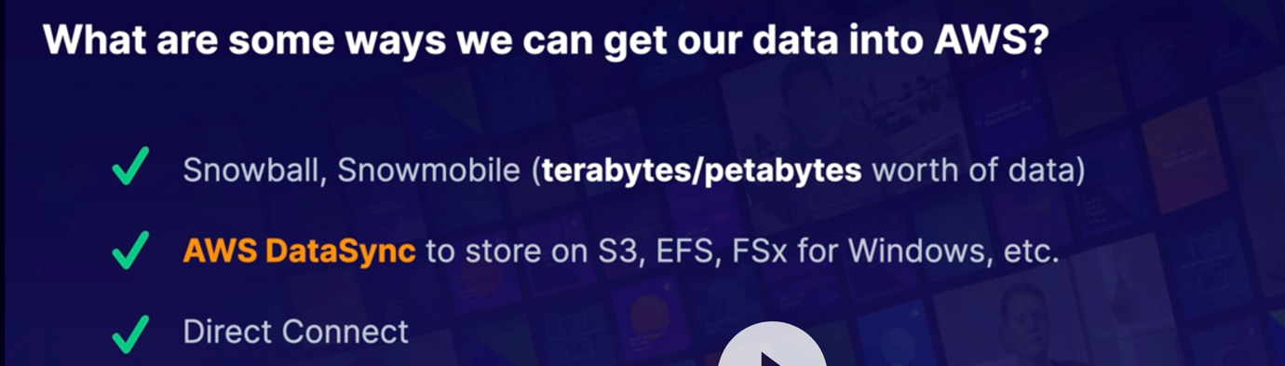

1. Compute and networking

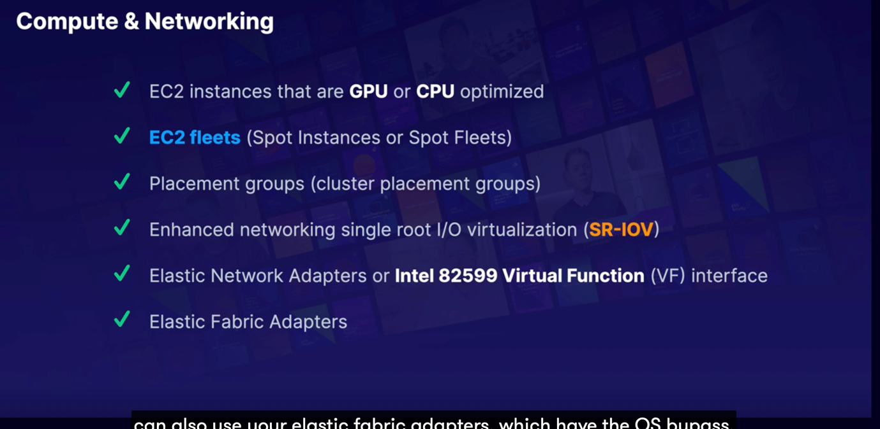

1. Storage solutions

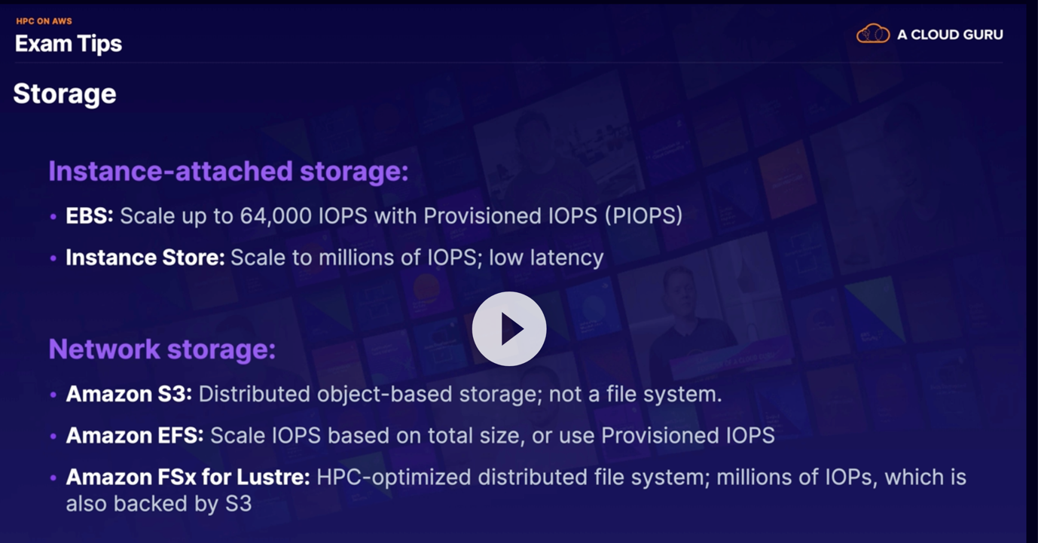

1. Orchestration and automation
   1. AWS batch
   2. AWS parallel cluster

**AWS WAF**

AWS WAF is a web application firewall that helps protect your web applications or APIs against common web exploits and bots that may affect availability, compromise security, or consume excessive resources. AWS WAF gives you control over how traffic reaches your applications by enabling you to create security rules that control bot traffic and block common attack patterns, such as SQL injection or cross-site scripting. You can also customize rules that filter out specific traffic patterns.

**EC2**

It's basically just a resizable compute capacity in the cloud, or it's a way of provisioning virtual machines in the cloud and it reduces the time required to obtain and boot new servers’ instances to minutes rather than hours or days or weeks or months, depending on where you work and it allows you to quickly scale capacity, both up and down as your computing requirements change.

**Pricing**So we have four different pricing models for EC2 we've got

**On Demand**, and this is where you pay a fixed rate by the hour or by the second with no long-term commitments,

**Reserved**. This is where you have a capacity reservation contract terms are one years or three years. The more you pay up front and the longer the contract term, the more discounts you get.

**Spot**. This enables you to bid whatever price you want for instance capacity, and t basically moves around like the stock market, and we then have **Dedicated Hosts,** and this is physical EC2 servers that are dedicated for you, and this can be a useful where you've got an existing server bound software license, or perhaps a regulation saying that you cannot use multitenant virtualization. Do you remember going into your exam that if a spot instance is terminated by EC2 because the price has changed, you're not going to be charged for that partial hour of usage. However, if you terminate the instance yourself, you are going to be charged for any hour in which the instance ran. We then looked at our different easy two instance types.

**EBS**

We learned that EBS is basically a virtual hard disk drive in the cloud. Remember that termination protection is turned off by default, so you must turn it on.

5.23 Better re-watch the video before the exam there is a lot of information !

**Databases   
  
DynamoDB**

Ask to Bastien about the problem of that tobn creates about the pull data maybe we can use a cache for that to solve it ?

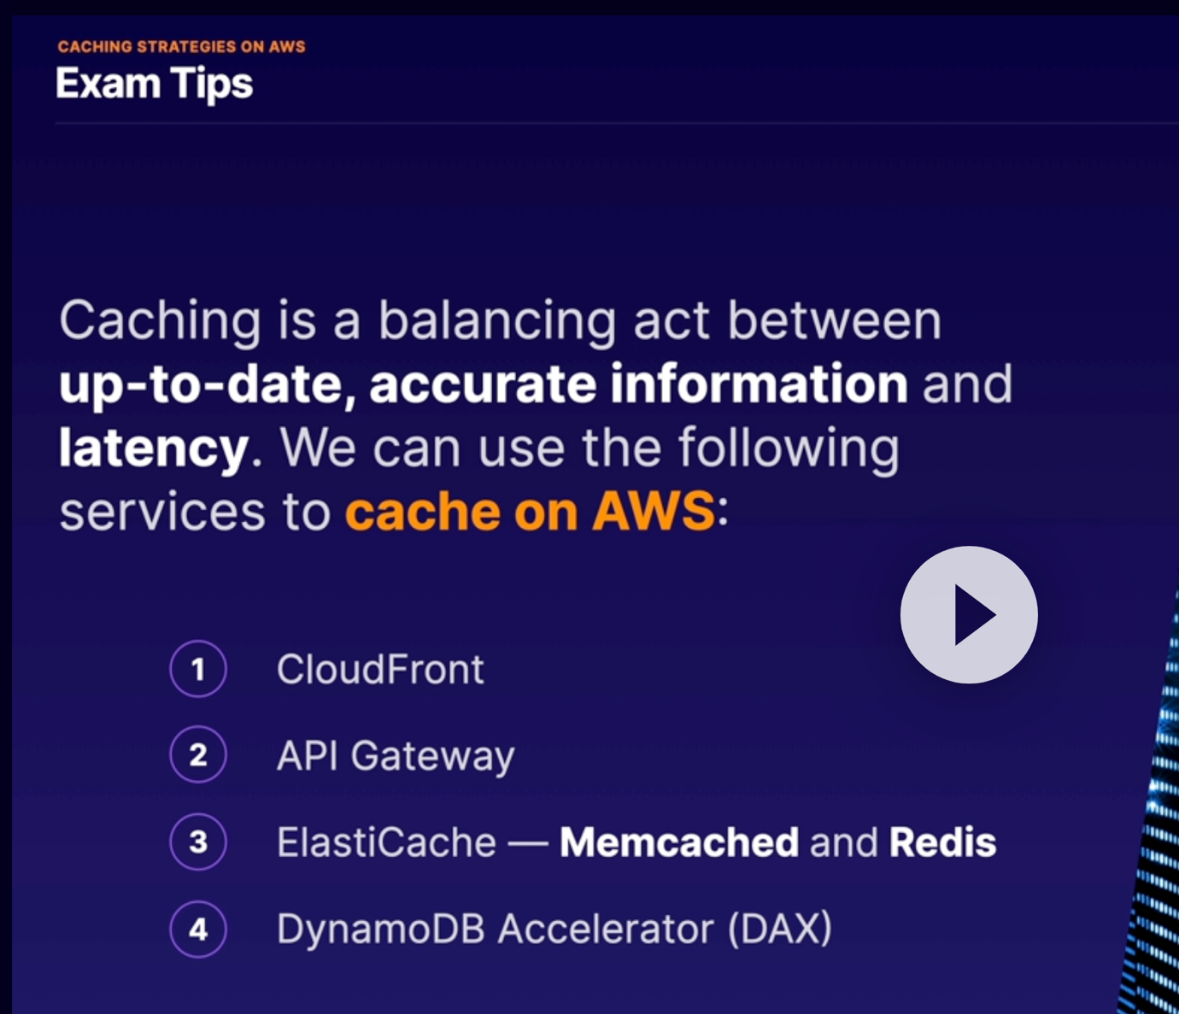

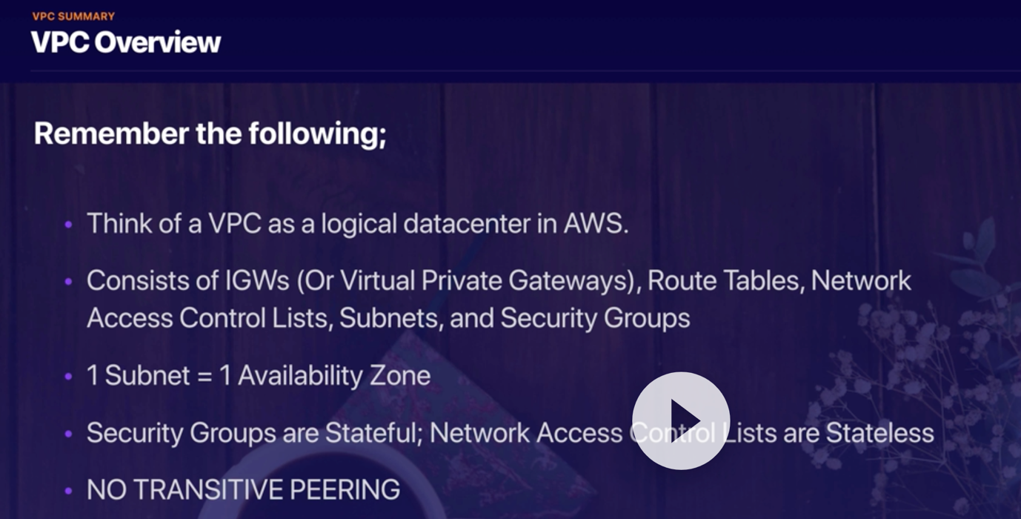

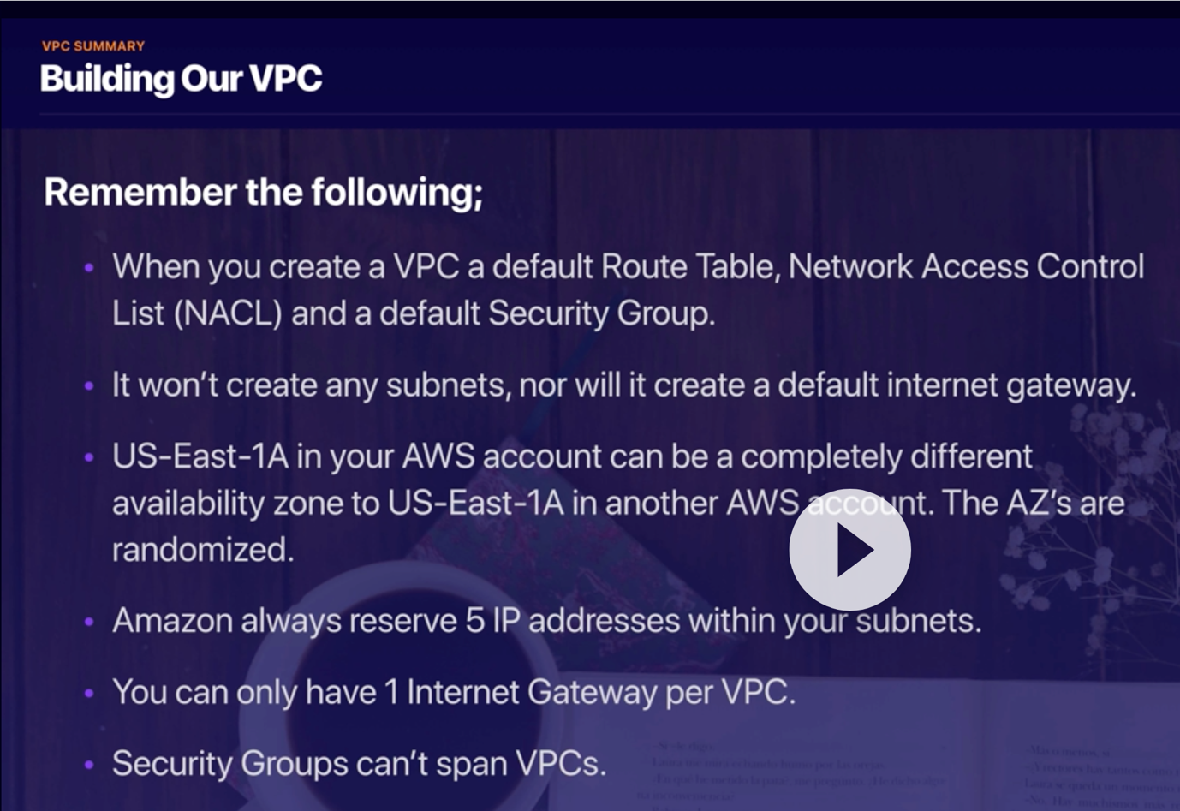

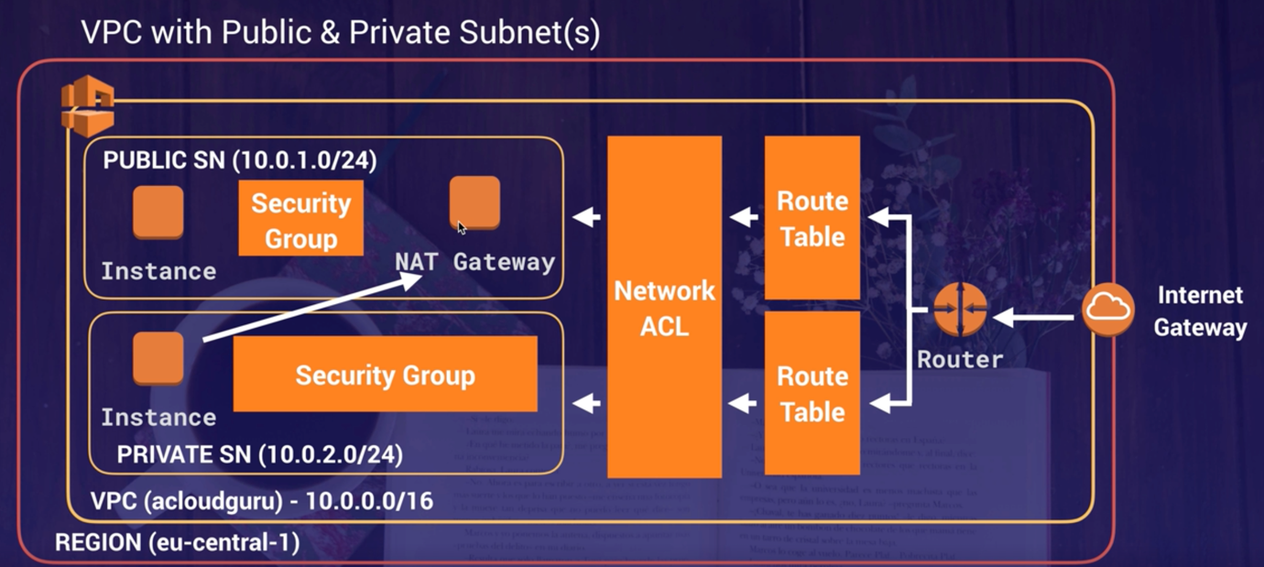

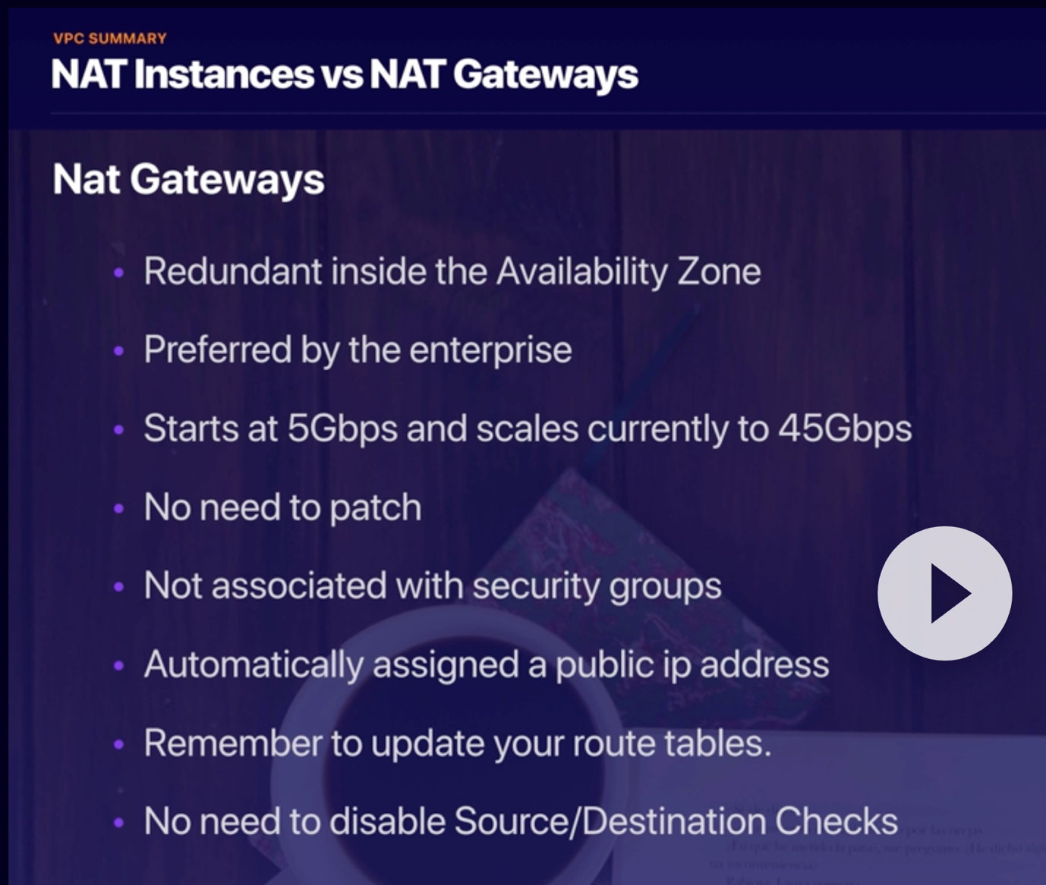

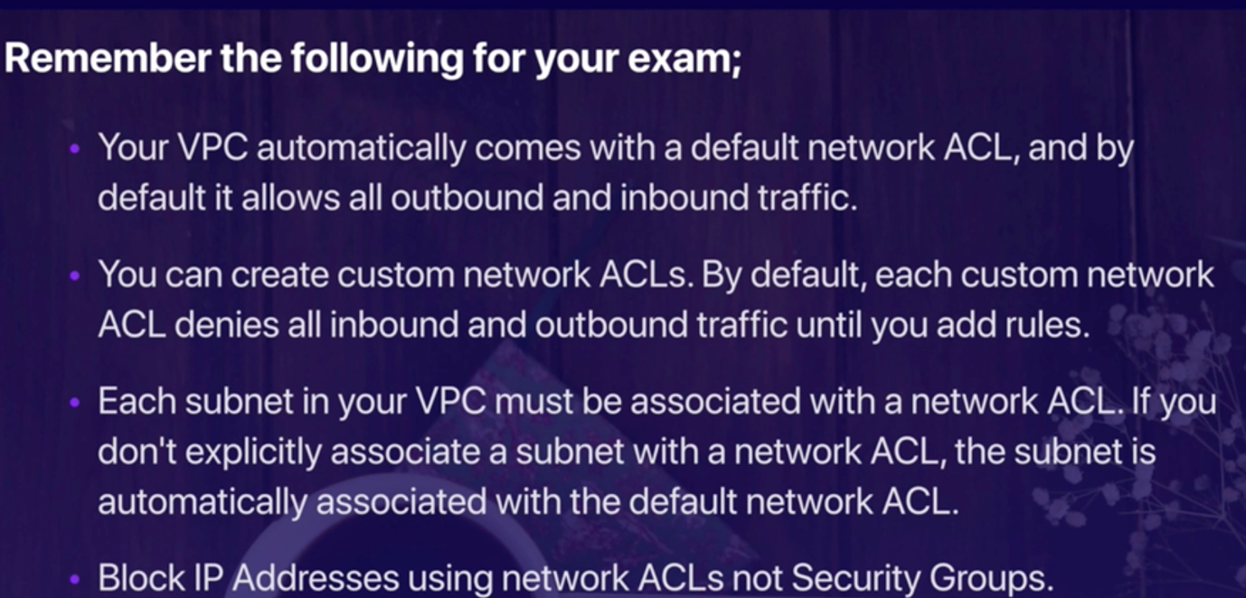

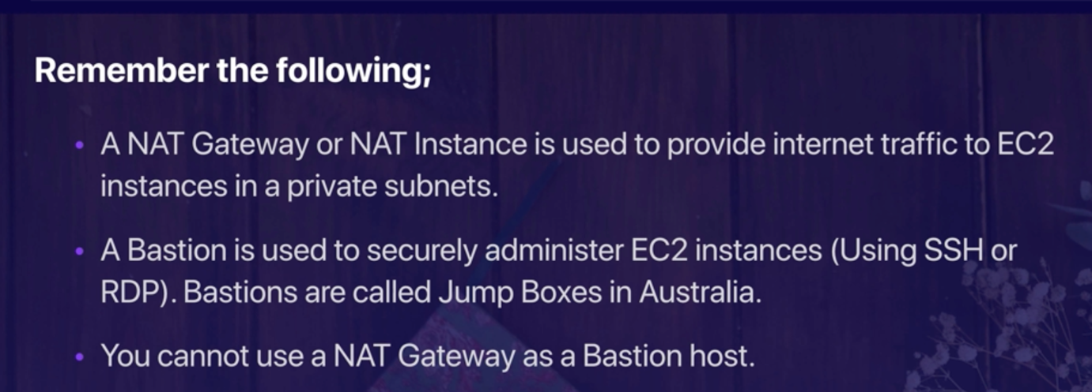

REDO the quiz 9.20